Project Title
Leaf Health Check

Team Leader :

MAHESWARI.V

Team member :

- SAMUNDEESWARI.M

- RINKU.A

- LOGESHWARI.M

- HARINI.S

Project Description
Monitoring plant health is a crucial activity in agriculture, horticulture, and home gardening. Traditional methods of detecting plant diseases require manual inspection, expert knowledge, and significant time investment. In many cases, early symptoms such as discoloration, spots, or texture changes on leaves are overlooked, leading to severe plant damage and reduced crop productivity. Leaf Health Check addresses this challenge by providing an AI-powered plant leaf analysis platform that delivers fast, accurate, and intelligent diagnosis.
Leaf Health Check is a smart application developed using the Streamlit framework that allows users to upload an image of a plant leaf and receive an instant health assessment. The system applies advanced image processing and deep learning techniques to examine visual symptoms such as yellowing, browning, and dark patches. These symptoms are analyzed through a discoloration detection logic that calculates the affected area and identifies possible signs of disease or nutrient deficiency.
The platform also includes a plant species identification module that compares the uploaded leaf image with a structured plant database. Once the plant type is recognized, the system performs disease prediction and evaluates the severity of the condition. Based on the percentage of damage and detected patterns, the leaf is classified into categories such as Healthy, Mild, Moderate, Severe, or Dying.
To make the system practical and user-friendly, Leaf Health Check generates a clear diagnosis along with three personalized rescue tips. These recommendations guide users in taking corrective actions such as adjusting watering schedules, applying fertilizers, improving sunlight exposure, or using suitable treatments.
By integrating artificial intelligence with an interactive web interface, the project transforms complex plant health monitoring into a simple, accessible, and real-time solution. The system is designed to assist farmers, students, researchers, and gardening enthusiasts in maintaining healthy plants without requiring expert-level knowledge. Leaf Health Check contributes to smart agriculture and sustainable plant care by enabling early detection and timely intervention.

Use Case Scenarios

Scenario 1: Leaf Image Upload and Health Analysis

Users upload a plant leaf image through the Streamlit interface. The system preprocesses the image by enhancing brightness, resizing it, and removing noise for accurate analysis. The AI model then detects discoloration patterns and predicts whether the leaf is healthy or affected by a disease. The result is displayed along with the severity level and confidence score.

Scenario 2: Plant Species Identification and Disease Detection
The system matches the uploaded leaf image with a plant species database. After identifying the plant type, it analyzes common diseases associated with that species and predicts the most probable condition. This ensures that the diagnosis is plant-specific and more accurate.

Scenario 3: Severity Grading and Rescue Recommendations
Based on the percentage of damaged area and the type of discoloration detected, the system assigns a severity level ranging from Healthy to Dying. It then generates three intelligent rescue tips that help users take immediate action to improve plant health and prevent further damage.

Architecture Overview
Leaf Health Check is an intelligent AI-powered plant disease detection system designed to analyze plant leaf images and provide accurate health diagnosis with actionable rescue recommendations. The application is built using the Streamlit framework and integrates a deep learning-based computer vision model to detect leaf discoloration, identify plant species, and determine disease severity.
The system processes uploaded leaf images, performs color analysis and species recognition, and delivers a structured diagnosis report including severity grading and personalized rescue tips.

Core Technologies
Streamlit: Web application framework for building interactive AI-based user interfaces
Python 3.8+: Backend processing and AI model integration
TensorFlow / PyTorch: Deep learning framework for plant disease classification
OpenCV: Image preprocessing and discoloration detection
NumPy & Pandas: Data processing and analysis
SQLite / PostgreSQL: Plant species and disease database management
Matplotlib / PIL: Image visualization and processing

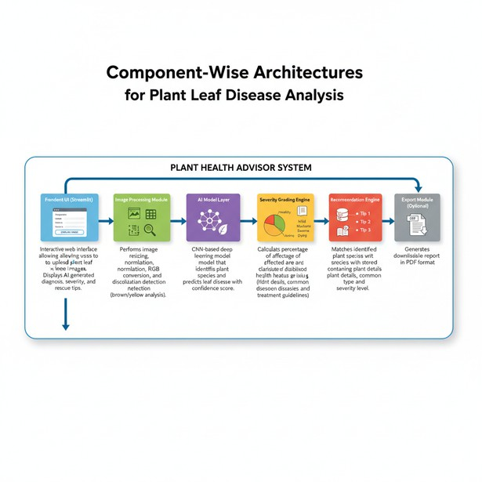

Component-Wise Architectures

System Workflow
Component

Frontend UI (Streamlit)

Image Processing Module

AI Model Layer

Severity Grading Engine

Species Database Lookup

Recommendation Engine

Export Module (Optional)
Description

Interactive web interface allowing users to upload plant leaf images. Displays AI- generated diagnosis, severity grading, and rescue tips.

Performs image resizing, normalization, RGB conversion, and discoloration detection (brown/yellow analysis).

CNN-based deep learning model that identifies plant species and predicts leaf disease with confidence score.

Calculates percentage of affected area and classifies health status (Healthy, Mild, Moderate, Severe, Dying).

Matches identified plant species with stored database containing plant details, common diseases, and treatment guidelines.

Generates three personalized rescue tips based on disease type and severity level.

Generates downloadable health report in PDF format.
- User uploads leaf image through Streamlit interface
- Image preprocessing (resize, normalize, noise reduction)
- Discoloration detection (yellow/brown pixel percentage analysis)
- AI model predicts:
Plant species Disease class
Confidence score
- Severity grading is calculated
- Rescue tips are retrieved from database
- Final diagnosis report is displayed

Severity Grading Logic
0–10% Discoloration → Healthy
11–30% → Mild
31–60% → Moderate
61–80% → Severe
81–100% → Dying

Severity is calculated based on:
Percentage of yellow/brown regions Disease probability score
Leaf texture damage

Output Format Diagnosis Report
Plant Name: <Identified Plant>Disease: <Predicted Disease>Confidence Score: <Model Accuracy %>Severity Level:
<Health Grade>

Rescue Tips:
- <Tip 1>
- <Tip 2>
- <Tip 3>

Deployment Architecture (Streamlit Based)

User → Streamlit UI → Image Processing → AI Model → Severity Engine → Recommendation Engine → Output Display
The application can be deployed on:
Streamlit Cloud AWS / Azure
Local Server

Pre-requisites
- Python 3.8 or above
- Streamlit Framework
- TensorFlow / PyTorch
- OpenCV
- Required Libraries (requirements.txt) Example installation:

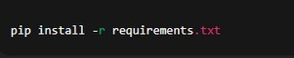

Run the application:

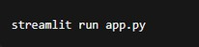

Project Workflow

AI Model Setup & Initialization

Activity 1.1: Setup Deep Learning Environment
Install Python and required AI libraries
Configure TensorFlow / PyTorch environment Download plant leaf disease dataset
Verify GPU/CPU compatibility for model training

Activity 1.2: Configure Environment and Dependencies
Create virtual environment
Install required packages using requirements.txt Configure model loading paths
Setup image preprocessing configurations

Activity 1.3: Prepare Detection Logic
Design discoloration detection algorithm Define yellow and brown color thresholds Prepare plant species classification labels
Test preprocessing with sample leaf images

Core Functionality Development

Activity 2.1: Design Streamlit Application Structure
Create main Streamlit interface (app.py) Build modular folder structure
Implement navigation and layout components Configure session state handling

Activity 2.2: Implement Image Upload Module
Upload JPG/PNG leaf images

Validate image size and format
Display preview of uploaded image
Add loading indicator during analysis

Activity 2.3: Develop AI Prediction Pipeline
Perform image preprocessing
Run species identification model Detect disease class
Calculate prediction confidence score

Backend Processing Implementation

Activity 3.1: Image Processing Module
Resize and normalize images Convert images to RGB format Remove noise using filtering
Extract discoloration regions using OpenCV

Activity 3.2: Severity Grading Engine
Calculate percentage of affected pixels Apply grading logic:
Healthy Mild
Moderate Severe
Dying
Combine discoloration + AI prediction results

Activity 3.3: Species Database Integration
Create plant species database
Map detected species with diseases
Store treatment and care information Retrieve matching plant details

Activity 3.4: Recommendation Engine
Generate rescue tips based on disease Adjust tips according to severity level
Ensure minimum three actionable suggestions

UI Development (Streamlit)

Activity 4.1: Build Interactive Interface
Application title and description

Image upload widget Analyze button
Progress spinner during processing

Activity 4.2: Implement Result Display
Show detected plant species Display disease diagnosis
Show severity badge
Display confidence percentage Present rescue tips clearly

Activity 4.3: Add Export Functionality (Optional)
Generate downloadable diagnosis report PDF export option
File naming and download handling

Testing & Optimization

Activity 5.1: Functional Testing
Test with multiple plant species images Validate discoloration detection
Verify severity grading accuracy Check UI responsiveness

Activity 5.2: Model Evaluation
Measure prediction accuracy
Validate classification confidence Reduce false predictions
Improve preprocessing quality

Activity 5.3: Performance Optimization

Optimize image processing speed Reduce model loading time
Improve Streamlit responsiveness
Handle invalid or low-quality inputs

Activity 5.4: Deployment Readiness
Prepare requirements.txt
Configure Streamlit Cloud deployment
Test application in production environment Ensure cross-platform compatibility

MILESTONE1:

GeminiAI Initialization

MILESTONE 1: AI Model Initialization

In this foundational stage, the objective is to establish and configure the core AI infrastructure required for the Leaf Health Check system. The platform utilizes a deep learning–based computer vision model to analyze plant leaf images, detect discoloration patterns, identify plant species, and generate health diagnosis with rescue recommendations.

Activity 1.1: Setup Development Environment and AI Model

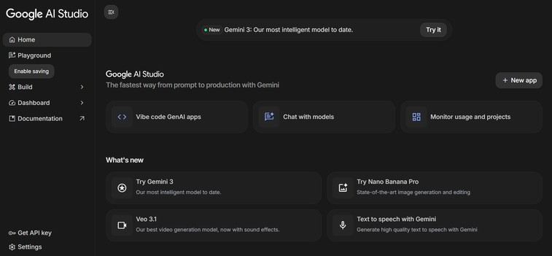

- Install Required Software
Install Python (version 3.8 or above)
Install required IDE (VS Code / PyCharm)
Setup virtual environment for project isolation

Install Required Libraries

- Prepare AI Model
Download plant leaf disease dataset
Configure trained CNN model (TensorFlow/PyTorch) Store trained model file inside /model directory
Verify model loading functionality

Activity 1.2: Configure Environment and Test Setup
- Create. env File

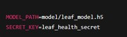

- Load Environment Variables Example configuration code:

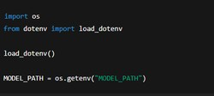

- Test Model Loading

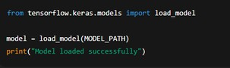

Expected Result:
Model loads without errors Ready for prediction testing

Activity 1.3: Validate Image Processing and Prediction

Test Image Preprocessing

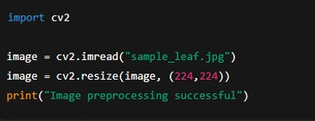

Test Disease Prediction

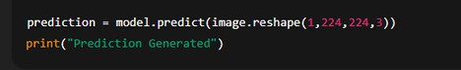

Expected Output:
Model predicts plant disease class
Confidence score generated successfully

MILESTONE 2: Core Functionalities Development
This milestone focuses on building the core application using the Streamlit framework integrated with the Google Gemini API. The system accepts plant leaf images, processes visual information, analyzes discoloration patterns, and generates an AI-based diagnosis with severity grading and rescue recommendations.

File Explorer Structure

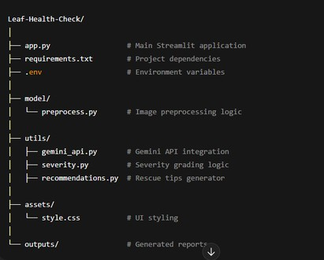

Activity 2.1: Streamlit Initialization and Import Libraries

Import Required Libraries

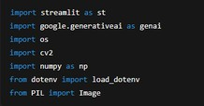

Initialize Environment and Gemini API

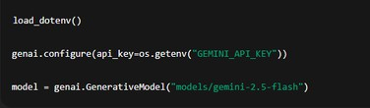

Activity 2.2: Main Functionality – Leaf Analysis Routing

Image Upload Interface

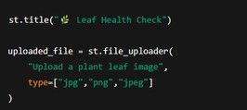

Image Processing

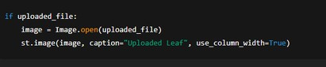

Gemini AI Diagnosis Request

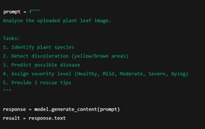

Display Result

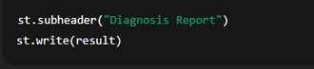

Activity 2.3: Severity Grading Logic

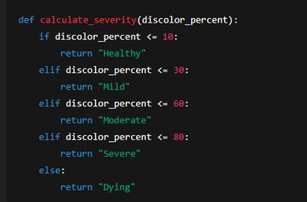

Activity 2.4: Export Functionality

Generate Text Report

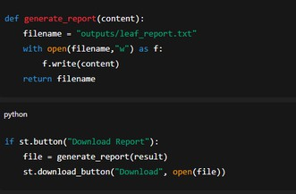

Activity 2.5: Utility Functions

Clean AI Response

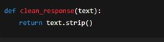
Unique File Generator
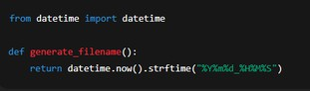

MILESTONE 3: Backend – Streamlit Integration (app.py)
This milestone focuses on implementing the complete backend logic inside the Streamlit application, integrating the Google Gemini AI Studio API, handling image processing, performing diagnosis generation, and enabling export functionality. The system ensures proper validation, structured responses, and smooth interaction between the UI and AI services.

Activity 3.1: Complete Function Definitions
All backend processing is implemented with: Input image validation

Error handling mechanisms
Gemini API response handling Logging and debugging support
Structured diagnosis output formatting Image Validation Example

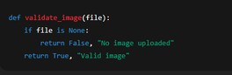

Activity 3.2: Modular Architecture
Main Application Structure

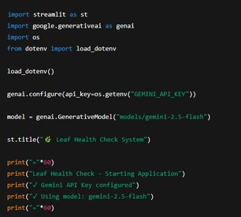

The Streamlit application directly manages:
User interaction
AI communication
Diagnosis generation Result visualization

Activity 3.3: Gemini AI Diagnosis Integration
Generate Diagnosis from Image

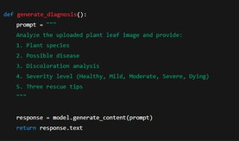

Display AI Response

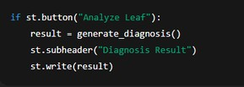

Activity 3.4: Export Implementation

Complete export functionality includes:
Diagnosis report generation
Downloadable text/PDF report File management and naming
Report Generation

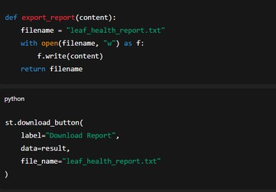

Activity 3.5: Error Handling and Response Formatting

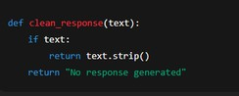

MILESTONE 4: UI Development
This milestone focuses on designing and implementing a user-friendly and responsive interface for the Leaf Health Check application using the Streamlit framework. The UI ensures smooth interaction between the user and the AI system, enabling easy image upload, analysis execution, and result visualization.

Activity 4.1: Home Page Development

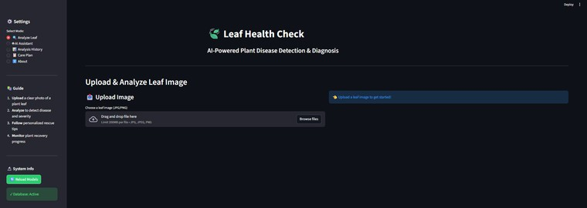

The home page acts as the primary interface for user interaction and provides clear guidance on how to use the application.

Home Page Features:
Application title and description Leaf image upload section
Supported image format information
Analyze button for triggering diagnosis Clean and responsive layout

UI Design Considerations:
Simple and minimal design Clear instructions for users
Responsive layout across screen sizes Intuitive navigation flow

Activity 4.2: Leaf Analysis Page

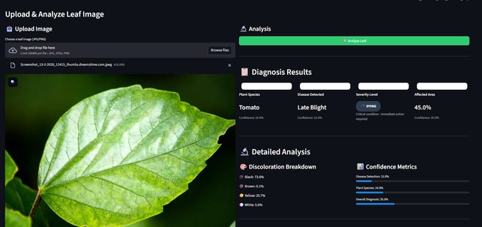

This section handles user input and displays AI-generated results after analysis.

Features Implemented:
Image preview after upload
Loading spinner during analysis Gemini AI diagnosis display
Plant species identification Disease detection result
Severity grading badge

Severity Levels Displayed:
Healthy Mild
Moderate Severe
Dying

Activity 4.3: Rescue Recommendation Display

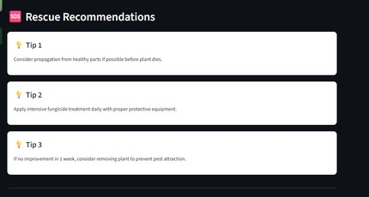

After diagnosis, the system presents actionable rescue recommendations to help users treat the affected plant.

Rescue Tips Section Includes:

Three personalized rescue tips
Tips based on disease type and severity Easy-to-read bullet format
Practical and actionable suggestions

Activity 4.4: Result Export Option

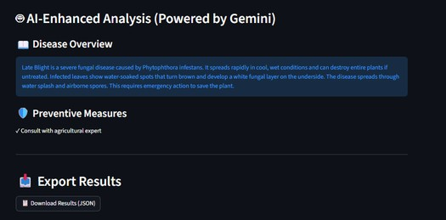

To enhance usability, the UI provides an option to download the diagnosis report.

Export Features:
Download diagnosis as a text/PDF report Automatically generated report name
Includes plant name, disease, severity, and tips

Activity 4.5: Error Handling and User Feedback

Proper feedback mechanisms are integrated to improve user experience.

Handled Scenarios:

Invalid image format No image uploaded AI response failure
Low-quality image warning

Feedback Methods:
Warning messages Error alerts
Success notifications
MILESTONE 5: Testing & Optimization
This milestone focuses on comprehensive testing, quality evaluation, and performance optimization of the Leaf Health Check application to ensure accuracy, reliability, and smooth user experience. Multiple test scenarios were executed to validate image analysis, AI diagnosis, severity grading, and rescue recommendations.

Activity 5.1: Comprehensive Testing

Test Scenarios
- Leaf Image Analysis
Input Type: Plant leaf images
Formats Tested: JPG, PNG, JPEG
Conditions: Healthy, diseased, partially damaged leaves
Expected Output: Accurate diagnosis with severity grading and rescue tips

Test Cases Executed:
Healthy green leaf image Yellowing leaf image
Brown spot infected leaf
Severely damaged leaf image
Low-quality and blurred images

- Discoloration Detection
Colors Tested: Yellow, brown, black
Severity Levels Verified: Healthy, Mild, Moderate, Severe, Dying
Expected Result: Correct severity classification based on affected area

- Gemini AI Diagnosis Testing
API Used: Gemini AI Studio API Key Model Tested: Gemini Vision Model Expected Output:
Plant species identification
Disease prediction
Confidence-based severity grading Three actionable rescue tips

- Error Handling Scenarios
No image uploaded
Unsupported image format Corrupted image file
API response delay or failure Expected Behavior:
User-friendly error messages
Graceful failure handling No application crash

Activity 5.2: Quality Evaluation

The output quality of the system was evaluated using the following metrics:
Diagnosis Accuracy
Severity Classification Correctness Relevance of Rescue Tips
Response Consistency User Interface Clarity Report Export Quality
Each test output was manually reviewed to ensure logical correctness and practical usefulness.

Activity 5.3: Performance Optimization

Improvements Made

Faster image preprocessing using optimized resizing Reduced Gemini API response latency
Improved input validation logic
Optimized Streamlit layout rendering
Added loading indicators for better user feedback
Reduced unnecessary re-computation using session state

Activity 5.4: Final Validation

After optimization, the system was re-tested to confirm:
Stable application performance Accurate AI predictions
Correct severity grading Smooth UI interaction
Successful report downloads

Conclusion
The Leaf Health Check project successfully demonstrates the application of AI-powered image analysis to assist in early plant disease detection and health assessment. By integrating the Streamlit framework with Google Gemini AI Studio, the system efficiently analyzes plant leaf images to identify possible diseases, detect discoloration patterns, determine severity levels, and provide actionable rescue recommendations.
The application processes user-uploaded leaf images in real time, leveraging Gemini’s advanced vision and reasoning capabilities to generate accurate and meaningful diagnosis reports. The intuitive and responsive Streamlit interface ensures ease of use, allowing users to quickly upload images, view analysis results, and download reports without technical complexity. The system emphasizes reliability, usability, and performance through structured testing, optimization, and effective error handling.
Overall, Leaf Health Check serves as a smart digital assistant for farmers, gardeners, and agricultural enthusiasts by enabling timely plant health assessment and informed decision-making. The project highlights the potential of AI-driven solutions in modern agriculture and lays a strong foundation for future enhancements such as multi-crop support, real-time camera integration, and advanced disease prediction models, contributing to sustainable and technology-driven farming practices.

